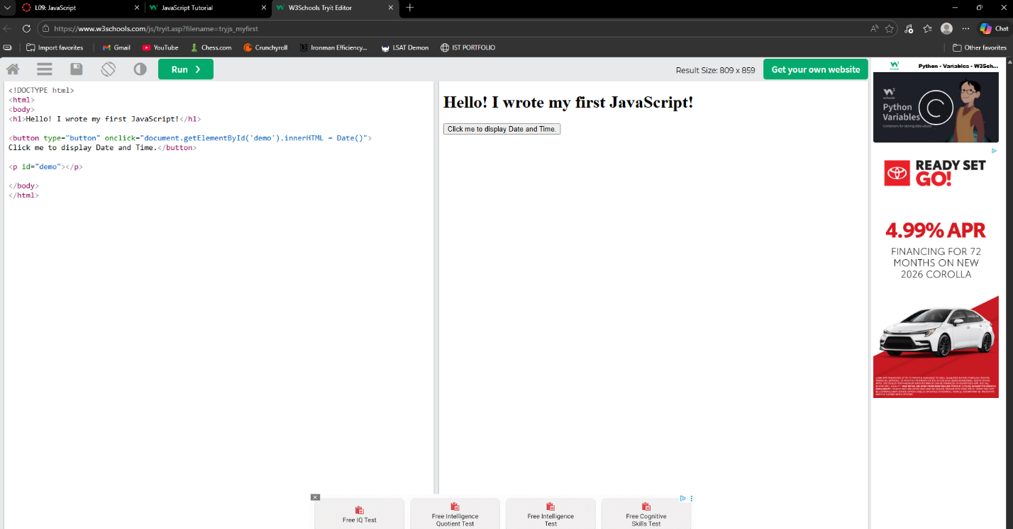
The two examples use JavaScript differently. In the first example, the code runs automatically when the page loads, displaying output immediately. In the second example, the code is connected to an event using an onclick function, meaning it only runs when the user clicks the button.
The code in the JS Events example is activated because of the event handler. Specifically, the onclick event tells the browser to execute the JavaScript only when the button is pressed, making it interactive instead of automatic.
The if, else, and else if statements are all used to control decision making in JavaScript. The if statement checks a condition, the else statement provides an alternative if the condition is false, and the else if statement allows multiple conditions to be checked in sequence.
The best control structure is the else if statement because it allows multiple conditions to be evaluated in a clear and organized way. This makes it more flexible and useful for handling more complex decision making compared to just using if or if else alone.
